For marine applications using Danfoss IC7-class drives, a continuous VFD cable with 360° bonded shields at both ends is best.
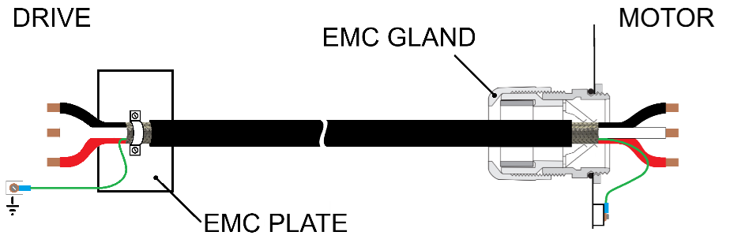
Any VFD cable interruption is treated as an EMC boundary. The motor cable shield is terminated 360° to the disconnect enclosure at entry and exit, and the enclosure is bonded to Permanent Earth with a short, wide connection. The enclosure itself provides shield continuity, preventing high-frequency common-mode currents from coupling into the vessel structure.
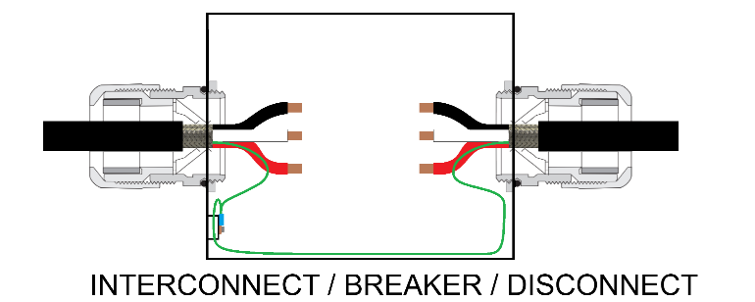

Shield handling rules (marine-tailored)
- Treat the disconnect box as an EMC enclosure
Per Danfoss IC7 and ABB marine guidance:
- Any metallic interruption becomes part of the EMC system
- Shield must see metal immediately at entry
Marine rule:
If the VFD cable enters it, the shield bonds to it.
- 360° shield termination at all four boundaries
At each of the following:
- VFD cabinet
- Disconnect box (IN)
- Disconnect box (OUT)
- Motor terminal box
Method
- EMC gland or 360° clamp
- Direct bond to bare metal enclosure wall
- No pigtails
- No terminal-block landings
This aligns with:
- IEC 61800-3 (minimize HF impedance, not DC resistance)
- Danfoss IC7 installation guidance
- ABB marine VFD practices
- The enclosure is the shield bridge
Do not splice the braid end-to-end inside the box.
Correct concept:
- Cable A shield → 360° bonded to box
- Cable B shield → 360° bonded to box
- Box wall provides continuity
This avoids:
- HF loops
- antenna stubs
- unpredictable shield current paths
- Bond the disconnect box to Permanent Earth — the right way
- Use a short, wide braided ground strap
- As straight as possible
- Bond to:
  - the same local Permanent Earth node used by the VFD system
  - not directly to the hull unless that is your defined Permanent Earth reference
Width beats gauge. A 25 mm braided strap outperforms a 2/0 AWG wire at high frequency.
- Keep High Frequency currents out of the hull
In towboats, hull current = noise + corrosion risk.
Therefore:
- Shield → enclosure → Permanent Earth → VFD common-mode network
- Not: Shield → Permanent Earth wire → vessel structure → motor
This is where many “works on land, fails on boats” installs go wrong.
Internal disconnect-box layout (what inspectors never see)
Inside the disconnect box:
- Keep phases tightly bundled
- Route along enclosure wall, not mid-air
- No unnecessary conductor separation
- Minimize lead length from gland to switch
- Every enclosure wall is a 360° shield termination
- The disconnect box is part of the EMC chain, not a break
- PE bonding is short, wide, and local
- No shield currents are forced into the vessel structure
This reduces:
- loop inductance
- radiated magnetic fields
- switching noise inside the box
Do / Do-Not list
Do
- Use EMC-rated glands (not standard strain reliefs)
- Remove paint locally at shield bond points
- Use stainless hardware with serrated washers
- Bond motor frame directly to local structure in addition to Permanent Earth
Do Not
- Float shields at the disconnect
- Pigtail shields to studs
- Assume DC continuity = EMC continuity
- Route VFD power cable parallel to signal/encoder cabling

